Customer Shopping Behavior Analysis
1. Project overview
This project analyses customer shopping behavior using transactional data from 3,900 purchases across various product categories. The goal is to uncover insights into spending patterns, customer segment, product preferences and subscription behaviour to guide strategic decisions.

2. Dataset Summary

Rows: 3,900
Columns: 18
Key Features:
1. Customer demographic (age, gender, location, subscription status),
2. Purchase details (item purchased, category, Purchase amount, season, size, color),
3. Shopping behavior (discount applied, promocode used, previous purchases, frequency of purchases, review rating, shipping type)

3. Exploratory Data Analysis

We began with data preparation and cleaning in python:
Data loading using pandas
Exploration using df.info() to check structure and df.describe() to check for summary statistics.
Checked for null values or special characters
Feature engineering by creating age group columns and purchase frequency days
Verified if discount applied and promocode used were redundant so dropped promocode
Connected Python script to PostgreSQL and loaded the cleaned database for SQL analysis.

4. Data Analysis using SQL

We performed structured analysis in PostgreSQL to answer key business questions:
1. Revenue by gender
SELECT gender, SUM("purchase_amount_(usd)") as revenue
FROM customer
GROUP BY gender;
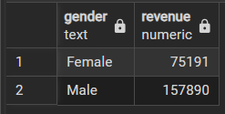
2. High spending discount user
SELECT customer_id, "purchase_amount_(usd)"
FROM customer
WHERE discount_applied = 'Yes' and "purchase_amount_(usd)">= (SELECT AVG("purchase_amount_(usd)") FROM customer);
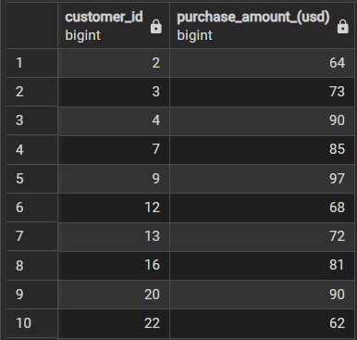
3. Top 5 products with highest average rated review
SELECT item_purchased, AVG(review_rating) as average_rating
FROM customer
GROUP BY item_purchased
ORDER BY average_rating desc
LIMIT 5;
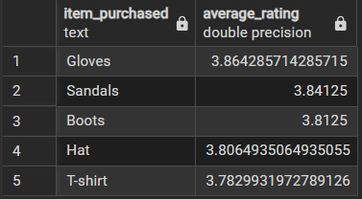
4. Average purchase amount between standard and express shipping
SELECT AVG("purchase_amount_(usd)") as average_purchase, shipping_type
FROM customer
WHERE shipping_type IN ('Express','Standard')
GROUP BY shipping_type;
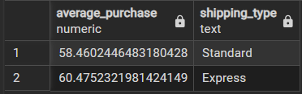
5. Revenue and subscription status
SELECT subscription_status,
SUM("purchase_amount_(usd)") as revenue,
ROUND(AVG("purchase_amount_(usd)"),2) as average_purchase,
COUNT(customer_id) as total_customers
FROM customer
GROUP BY subscription_status
ORDER BY revenue desc;
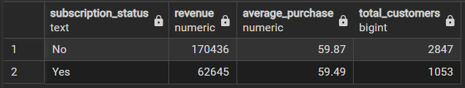
POWER BI DASHBOARD
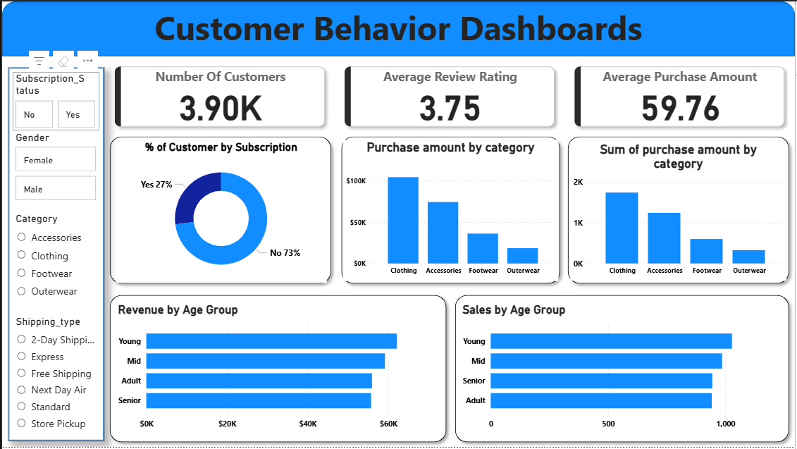
Business Recommendations
* Accelerate subscription growth by clearly communicating exclusive value propositions and premium benefits available only to subscribers.
* Deepen customer loyalty through enhanced rewards for repeat purchasers, strategically migrating them into the high-value “Loyal” segment.
* Optimize discounting strategy to drive incremental revenue while protecting margins and long-term profitability.
* Elevate product positioning by prioritizing top-rated and best-selling products across all marketing and promotional channels.
* Sharpen targeted marketing investments by concentrating spend on high-revenue demographics and customers with a strong preference for express shipping.

